State of Colorado
Department of State

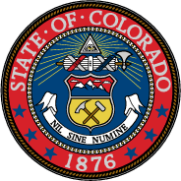

Electoral College Ballot
Office of Vice President of the United States of America
December 19, 2016

Tim Kaine, Vice President
Democratic Party

______________________________ ______________________________
Printed name of elector Signature of elector

