State of Colorado
Department of State

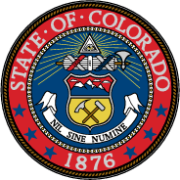

Electoral College Ballot
Office of President of the United States of America
December 19, 2016

Hillary Clinton, President
Democratic Party

______________________________ ______________________________
Printed name of elector Signature of elector

