Colorado Digital “I Voted” Sticker Partner Toolkit

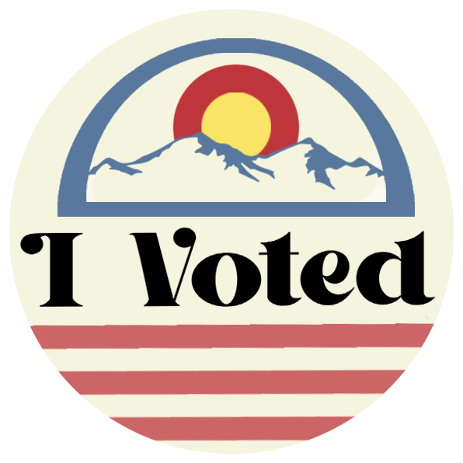
This kit includes:
- Link to I Voted Digital Sticker Contest website
- Link to I Voted Digital Sticker Template
- Link to Submission and Release form
- Contest Submission Dates
- Contest Description and Rules doc
- Sample social media posts
- Sample email to potential participants
- Sample email to distribution partners
Matthew H.’s winning digital
“I Voted” sticker design from 2022
- Link to printable flyer

Contest Submission Dates:
- August 1, 2024 – September 2, 2024

Contest Rules:
- All entrants must be 13 - 18 years old and enrolled in a Colorado high school or Colorado homeschool program.
- All artwork submitted must be your original work; no stock or borrowed images may be used.
- Artwork with offensive language, violence, drugs, gangs, weaponry, etc. will not be considered.
- Entries must include the words “I Voted”.
- Artwork must be nonpartisan.
  - Entries may be created on paper or digitally.
  - Paper entries must be either scanned or photographed clearly for submission.
- Digital & paper files must be under 1GB, and must be a .pdf, .png, .jpg, or jpeg.
- If the winner submitted artwork created on paper, the Colorado Secretary of State’s Office will provide a pre-paid envelope for the artwork to be mailed for image processing for the digital image, if necessary. The artwork will be returned to the artist after processing.
- Entries will be used for social media and other marketing materials for the Colorado Secretary of State’s Office.

Sample Social Media posts
- 📢 Colorado high schoolers! 📢
Whether you love politics, graphic design or both, now is your chance to design Colorado’s newest digital “I Voted” sticker! Submit your artwork through September 2 and encourage Coloradans to VOTE! Learn more at GoVoteColorado.gov.
- CO high schoolers can submit their designs NOW for the digital “I Voted” sticker through Sept. 2! Students can have their artwork featured on @CoSecofState's social channels and website -- and help encourage Coloradans to VOTE!
Learn more at GoVoteColorado.gov.

Sample Email to potential participants
Hello [NAME],
I hope you’re doing well!
The Colorado Secretary of State’s Office has announced a competition for students to submit artwork for a new digital “I Voted” sticker that runs until September 2. They are accepting design submissions from high school students for the contest.
The creator of the winning design will have their artwork featured on the Secretary of State’s website, media channels, and as part of digital effort to encourage people to vote across the state. It will also be sent directly to every Colorado voter enrolled in Colorado BallotTrax after they’ve cast their ballot. Nearly 2,000,000 Colorado voters are enrolled in BallotTrax!
I think it would be a great idea for you to submit artwork for consideration! You can learn more at www.GoVoteColorado.gov. And don’t forget to tell your friends!
Thanks, and let me know how I might be able to help.
[TK NAME]

Sample email to potential distribution partners
Hello [NAME],
[Introduce yourself].
I wanted to share an exciting opportunity for students from the Colorado Secretary of State’s Office. From August 1 – September 2, they’ll be accepting design submissions from high school students who want to help create a new, digital “I Voted” sticker for the November 5 general election.
The creator of the winning design will have their artwork featured on the Secretary of State’s website, media channels, and as part of digital effort to encourage people to vote across the state. The winning design will also be sent to all Colorado BallotTrax users after they have cast their ballot – there are nearly 2,000,000 voters that this could reach!
I’d love for you to spread the word about this opportunity. I’ve attached a flyer you can share that includes everything you need to know about the digital sticker contest.
Would you be willing to share this exciting opportunity with your channels?
Thanks, and please let me know if you have any questions!
[Name]

