# ePollbook Election Judge Guide (VSPC)

Access SCORE SANDBOX or PRODUCTION Environment 2

ePollbook Search Screen 3

Ballot Screen 6

Label Indicators 8

Identifying a Confidential Voter 9

Ballot Information Section 10

No Updates to Voter Registration 11

Issue an In Person-Paper or In Person-BMD Ballot by selecting the In Person-Paper or In Person BMD button: 11

Issue a Mail Ballot by selecting the Mail Ballot button 12

Print In Person-Paper or Mail Ballot – Runbeck BOD and Dominion MBP 13

Updating a Voter Record Before Issuing a Ballot 14

Registering a New Voter 17

Confined Voting - Voting Conducted at a Jail or Detention Center Facility 25

Addendum A – Spoil a Ballot 28

Addendum B – Undo Vote Credit 30

Addendum C - Transfer Ballot 32

Addendum C - Transfer Ballot Cleanup 35

Addendum D- Voter Has Multiple Records 38

Addendum E - (CDOR) Colorado Department of Revenue 39

Addendum F - (CDOC) Colorado Department 40

Addendum G - (CDPHE) Colorado Department of Health 41

## Access SCORE SANDBOX or PRODUCTION Environment

**Access SCORE SANDBOX Environment (training and learning environment):**

**Correct URL –** [**https://webscore-sandbox.coloradosos.gov**](https://webscore-sandbox.coloradosos.gov)

**Access SCORE PRODUCTION Environment (live environment):**

**Correct URL –** [**https://webscore.coloradosos.gov**](https://webscore.coloradosos.gov)

1. On the 3.0 Sandbox Dashboard select the *ePollbook* link: On the 3.0 Production Dashboard select the *ePollbook* link:

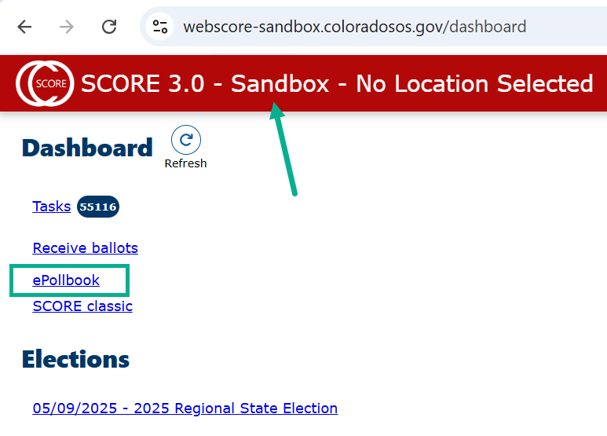 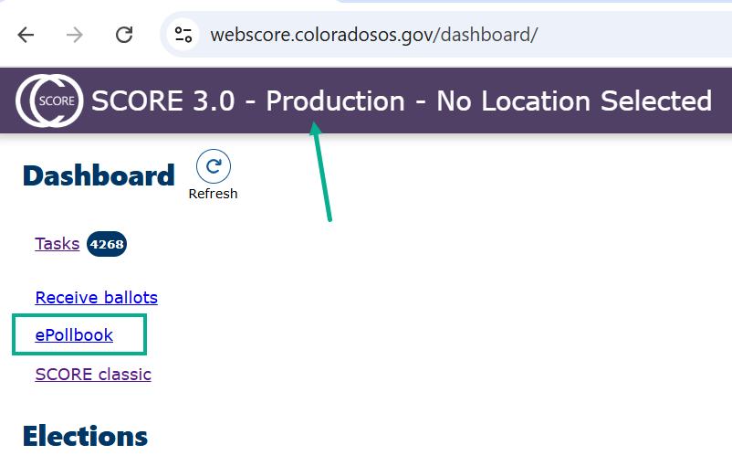

1. Confirm you are in **Sandbox ePollbook Search** screen: Confirm you are in **Production ePollbook Search** screen:

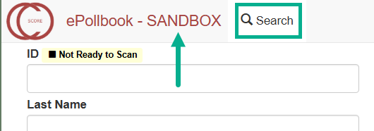 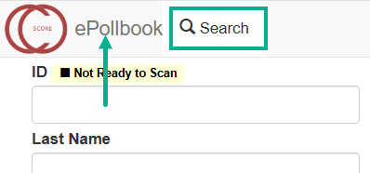

## ePollbook Search Screen

1. The ePollbook Search screen is the default home screen.

The top menu options remain static and are easily accessed from every screen.

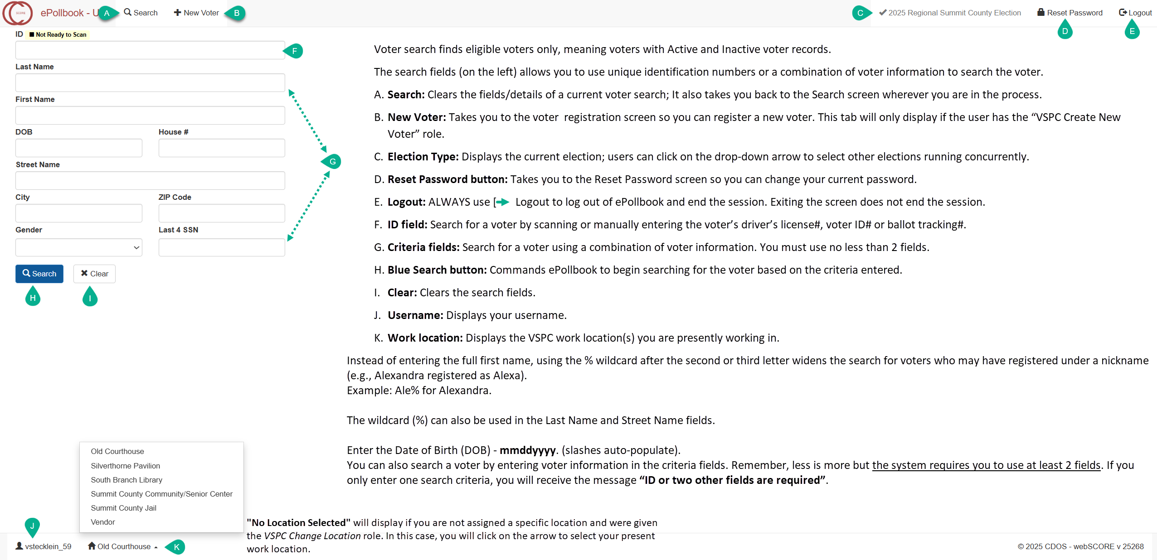

*ePollbook Search Screen (continued)*

Searching by Voter ID # or DL/ID # results in an exact match because it is unique to the voter.

There are two exceptions. ID voter searches will NOT result in a match if:

1. The voter is not registered (not registered includes cancelled and Incomplete); or

2. You searched by the Colorado DL/ID #, but the voter did not provide their Colorado DL/ID when they registered to vote.

If a voter cannot be found, you will receive the message “No Results”.

You are required to enter no less than two search criteria if not using a Voter ID# or Colorado DL/ID #.

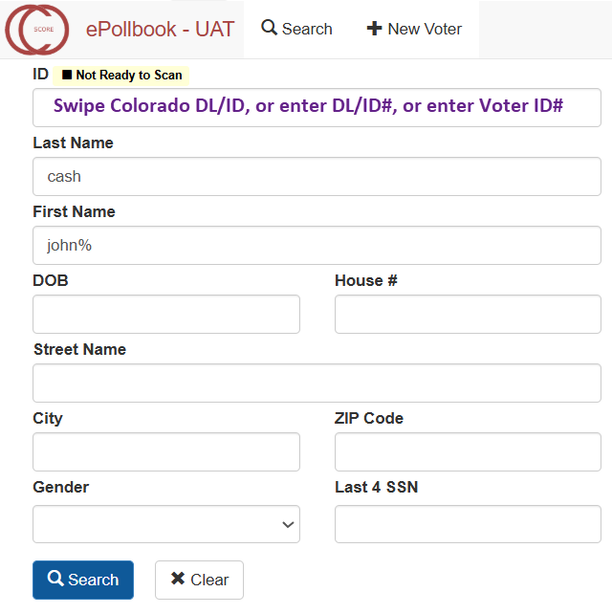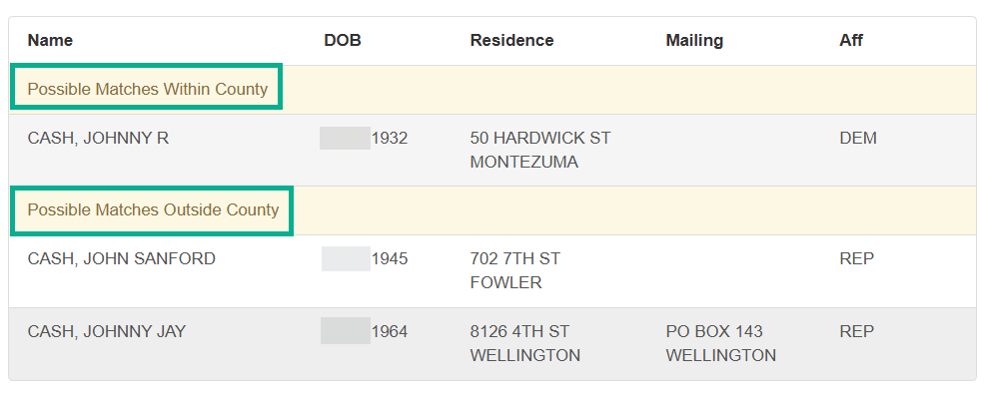

Click anywhere on the voter line to open the voter’s record to issue a ballot.

*ePollbook Search Screen (continued)*

The system will display a maximum of ten potential matches at a time.

If there are more than ten potential matches, you will receive a message to narrow the search criteria.

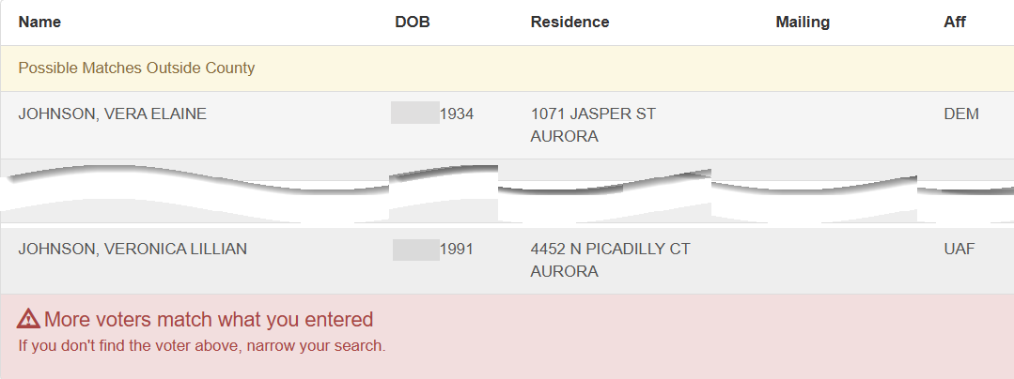

## Ballot Screen

Once you have clicked on the voter line from the Search screen, the Ballot screen will open.

This Ballot Screen has three sections:

1. The **Voter Information** section displays voter information that was provided on the registration form as entered in SCORE. Under “Name”, the system displays the voter’s present name (on top) and if the voter has a ***previous name(s)*** *–* it will displaybelow (as shown in the screenshot).
2. The **Ballot Information** section displays the history of ballots issued to the voter. However, this section will NOT display if the voter has never been issued an original mail ballot from your county (i.e., out of county voters, inactive voters, new voters, and ineligible voters will not have ballot information).
3. The **Issue a Ballot** section displays buttons for three different ballot types. These buttons will be disabled for ineligible voters (e.g., already voted, not in district or out-of-county).
4. There are three navigation buttons in the upper right corner of the screen:

* **Back to Results** button**:** Takes you back to the current search results.
* **Previous** button**:** Allows you to scroll upwards to view voter records from the search results.
* **Next** button**:** Allows you to scroll downward to view records from the search results.

*Ballot Screen (continued)*

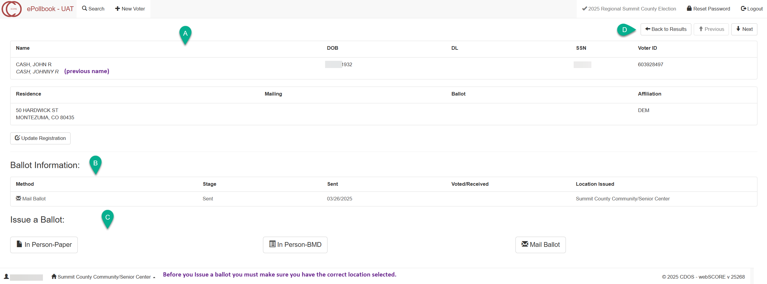

## Label Indicators

The Ballot screen may haveone or more label indicator(s) in the upper left corner to describe a voter’s status during the election cycle.

From left to right as they appear:

**Already Voted**:

Indicates the voter already cast their ballot and is not eligible to receive a second ballot!

ePollbook will not allow you to change the voter’s address or issue a ballot.

**ID Required:**

Indicates the voter must provide acceptable identification before voting the ballot.

**Inactive Voter:**

Indicates the voter’s record is not active. The voter’s registration will be made Active when a ballot is issued.

**Out of County**:

Indicates the voter is from another county. The voter’s registration must be updated to be able to issue a ballot from your county. However, if the voter is not updating their address to your county but want to vote at the VSPC the voter may be offered a Statewide Ballot.

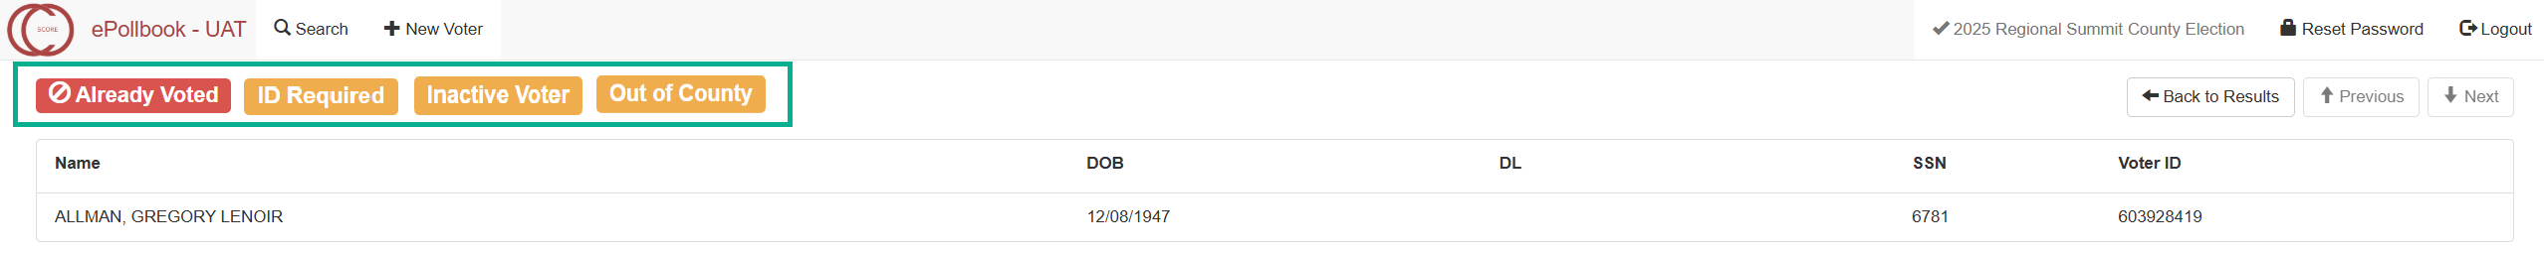

## Identifying a Confidential Voter

**Confidential Voters** are easily identified by a red label indicator shown in two places:

In the search results under the voter’s name.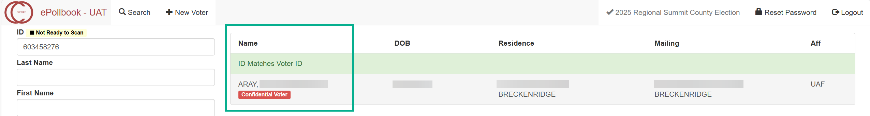

AND

In the upper left corner of the voter’s record in the Ballot Screen.

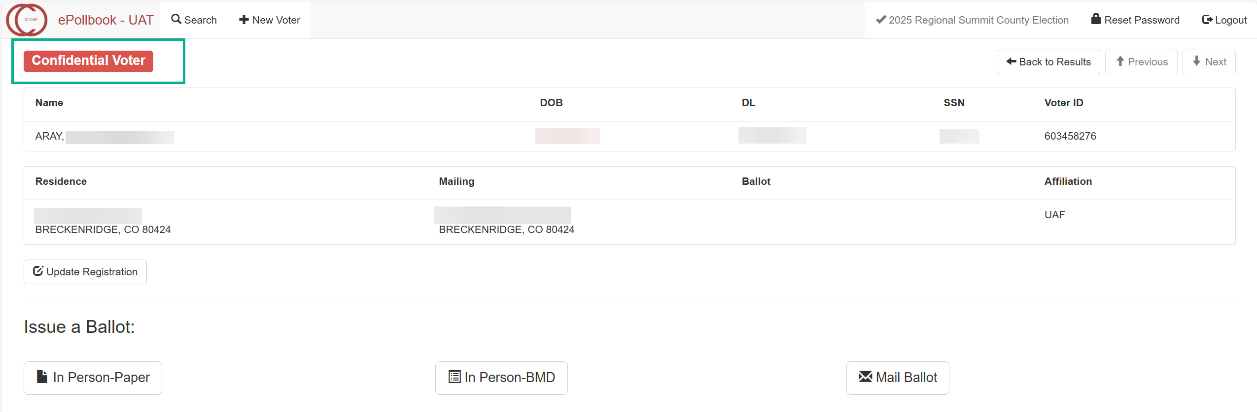

Follow your county’s business practice for processing Confidential voters.

## Ballot Information Section

The Ballot Information section provides detailed history of ballots.

As mentioned previously, the **“Already Voted”** label indicator is a quick, visual way to know that the voter is ineligible to vote another ballot. However, reviewing the voter’s **Ballot Information section** is equally important.

In this image, there are two ballot lines, which means this voter has been issued an original ballot and a second ballot. **The top ballot line is always the active ballot**, and the ballot lines beneath reflect the voided/spoiled ballot history.

**Method:** The type of ballot the voter was issued.

**Stage**: The present stage the ballot is in during the election cycle (i.e., sent, voted, undeliverable, spoiled, voided, undone). A voter cannot be issued another ballot if a previous ballot is in the “voted” stage!

**Sent:** The date the mail ballot was sent. In person voters will not have a sent date.

**Voted/Received:** The date the voter cast their In Person ballot or the date the Mail ballot was received.

**Location Issued:** The Location where the ballot was issued.

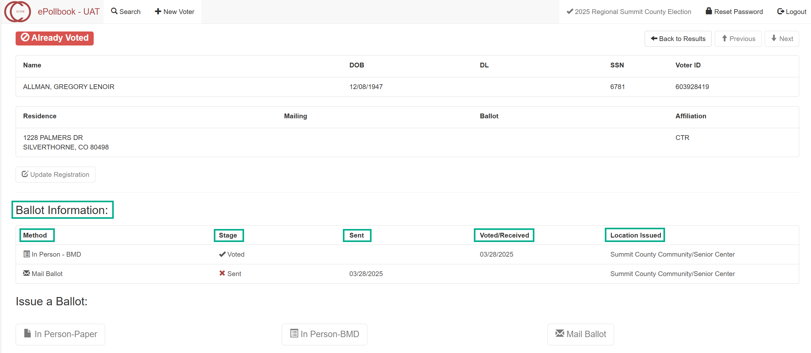

## No Updates to Voter Registration

Proceed to “Issue a Ballot”

Click anywhere on the voter line to open the voter’s record to issue a ballot.

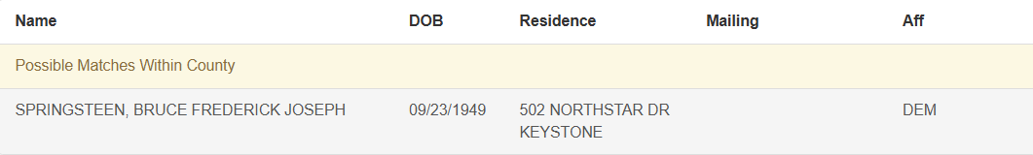

## Issue an In Person-Paper or In Person-BMD Ballot by selecting the In Person-Paper or In Person BMD button:

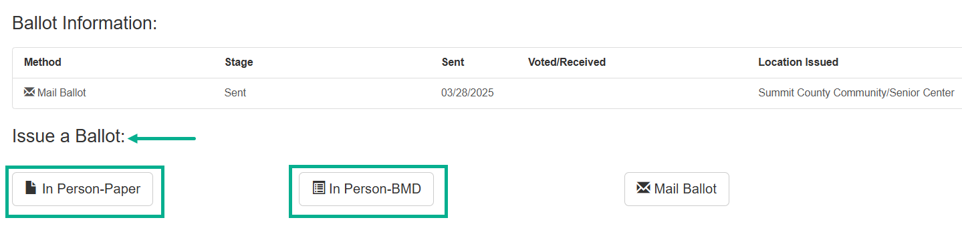

[Wait for the ballot label to generate]

Print the ballot label or Close the label screen (per your county’s business process). If a label is printed, affix the ballot label to the signature card.

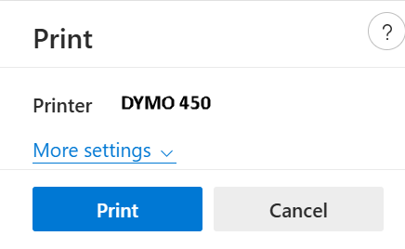Paper Ballot Label 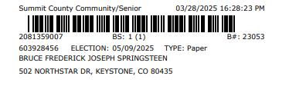 BMD Label 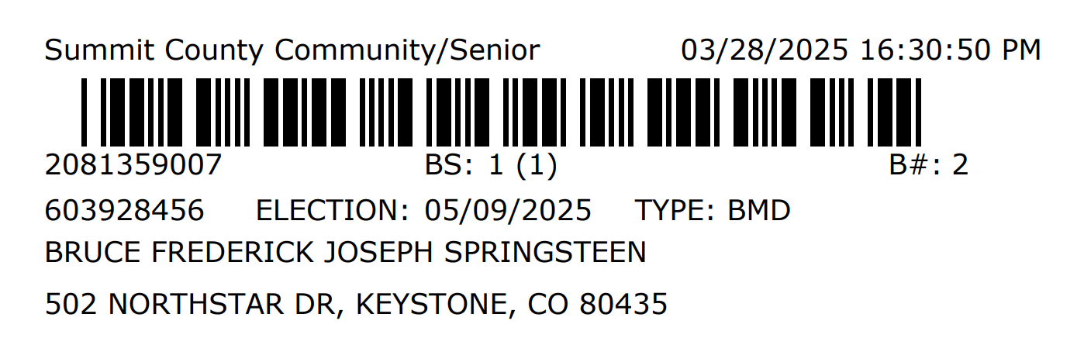

## Issue a Mail Ballot by selecting the Mail Ballot button

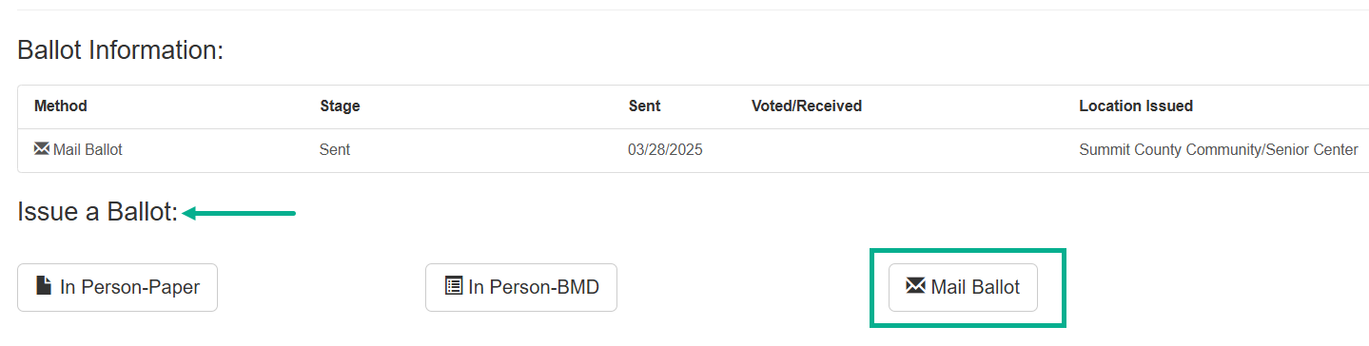

[Wait for the ballot label to generate]

Print the mail ballot label and affix the label to the mail ballot package.

 Mail Ballot Label 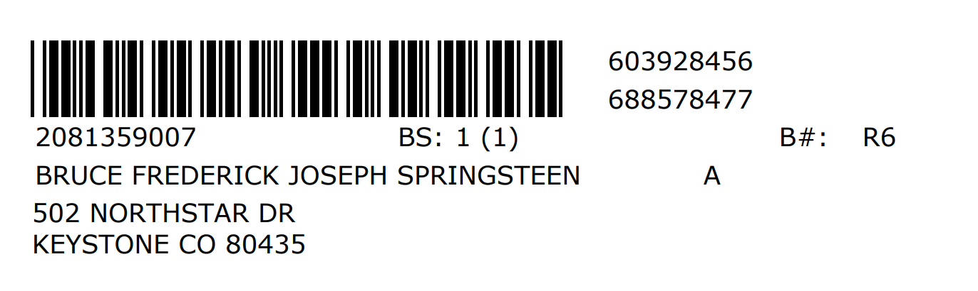

## Print In Person-Paper or Mail Ballot – Runbeck BOD and Dominion MBP

To print the ballot, select the **Ballot** button at the bottom of the Ballot Details screen. This will generate a ballot file for printing.

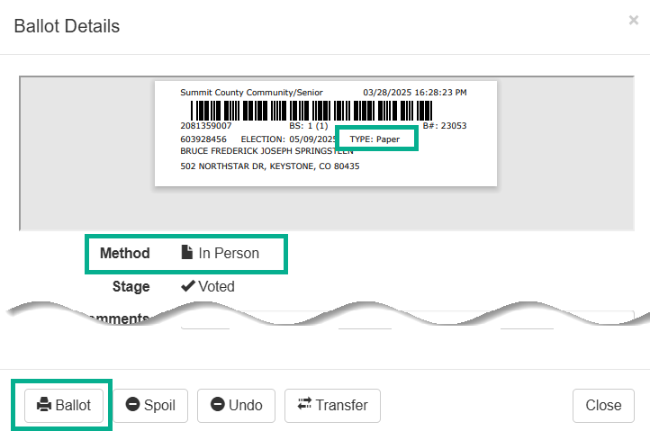 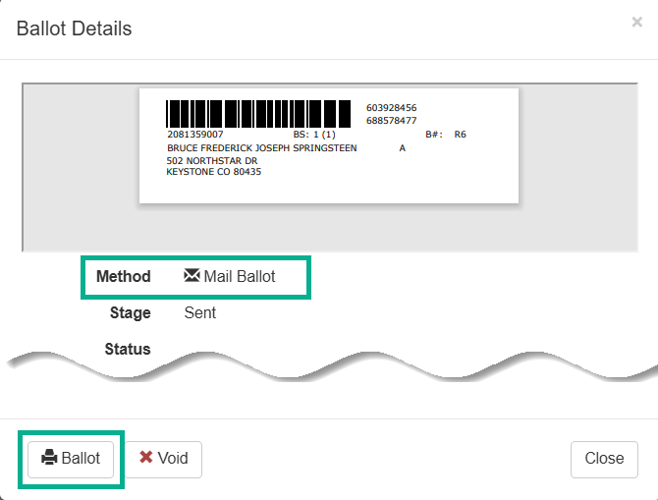

## Updating a Voter Record Before Issuing a Ballot

Capturing new voter information ***before*** issuing the ballot is critical. Updating the registration ensures the voter receives the correct ballot for which they are eligible to vote!

Before issuing the ballot, determine whether the voter’s registration needs to be updated. Compare the registration form or signature card to the information in the voter’s record.

* Is there a Name change?
* Has the voter added a Driver’s License# or SSN#?
* Has the Residential Address changed?
* Did the voter add, update, or remove a Mailing Address?
* Did the voter add, update, or remove a Ballot Address?
* Is there an Affiliation change?

You must have the **“VSPC Update Voter”** role to have access to the **Update Registration** button.

1. On the Ballot screen select the **Update Registration** button and the Voter Registration screen will open.

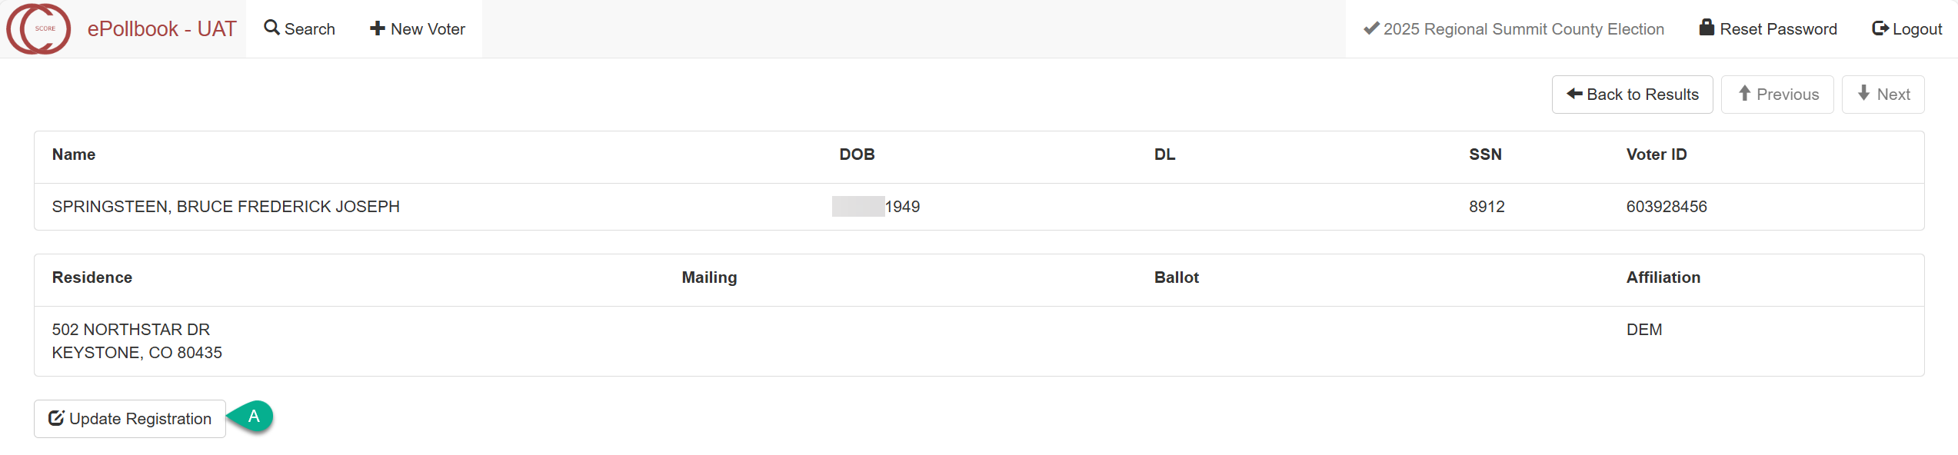

*Update a Voter Record (continued)*

In the following steps, it is important the user follow the fields on the screen to compare the voter information provided on the VSPC Signature Combo Form or signature card. This ensures information is not missed during data entry.

1. **US Citizen:** Defaults to “Yes” because it is an existing voter record.
2. Review the Keyline information, which is Name, Date of Birth, Gender, DL, SSN and click the **Edit Keyline** button if there is a change/addition **OR** click the No **Keyline Changes-Continue** button if there are no changes/additions.

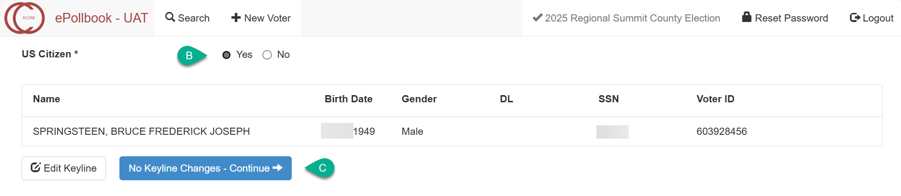

1. The Keyline fields would open for editing if you selected the **Edit Keyline** button.
2. Update the Keyline and select the **Continue** button to continue.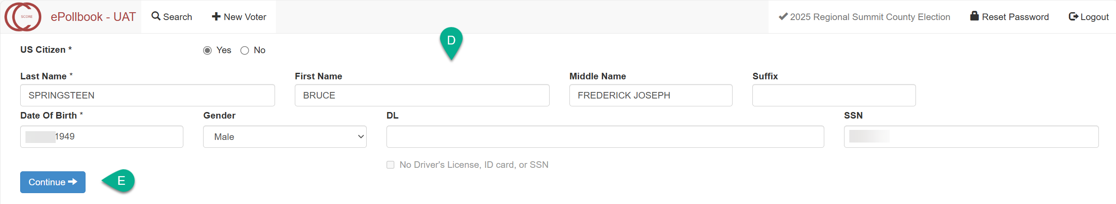

Changes to the voter’s Name and adding a DL number are potentially the most common edits made to the Keyline when a voter updates their registration. Although edits are not limited to just those two fields.

*Update a Voter Record (continued)*

When you select the **Continue** button the system will perform checks against state agency data and SCORE voter records. If the new voter information verifies against the system checks, you will proceed to the voter registration page and see the “**Proceed with Update”** message displayed.

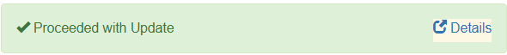

All fields are pre-populated with the existing voter information.

*Residence pre-populates for *within county* voters only and will not pre-populate for *out-of-county* voters as they are required to provide a new residence address.

Verify what information has changed in the voter’s record. Always select the **Clear** button first before making changes/updates to addresses.

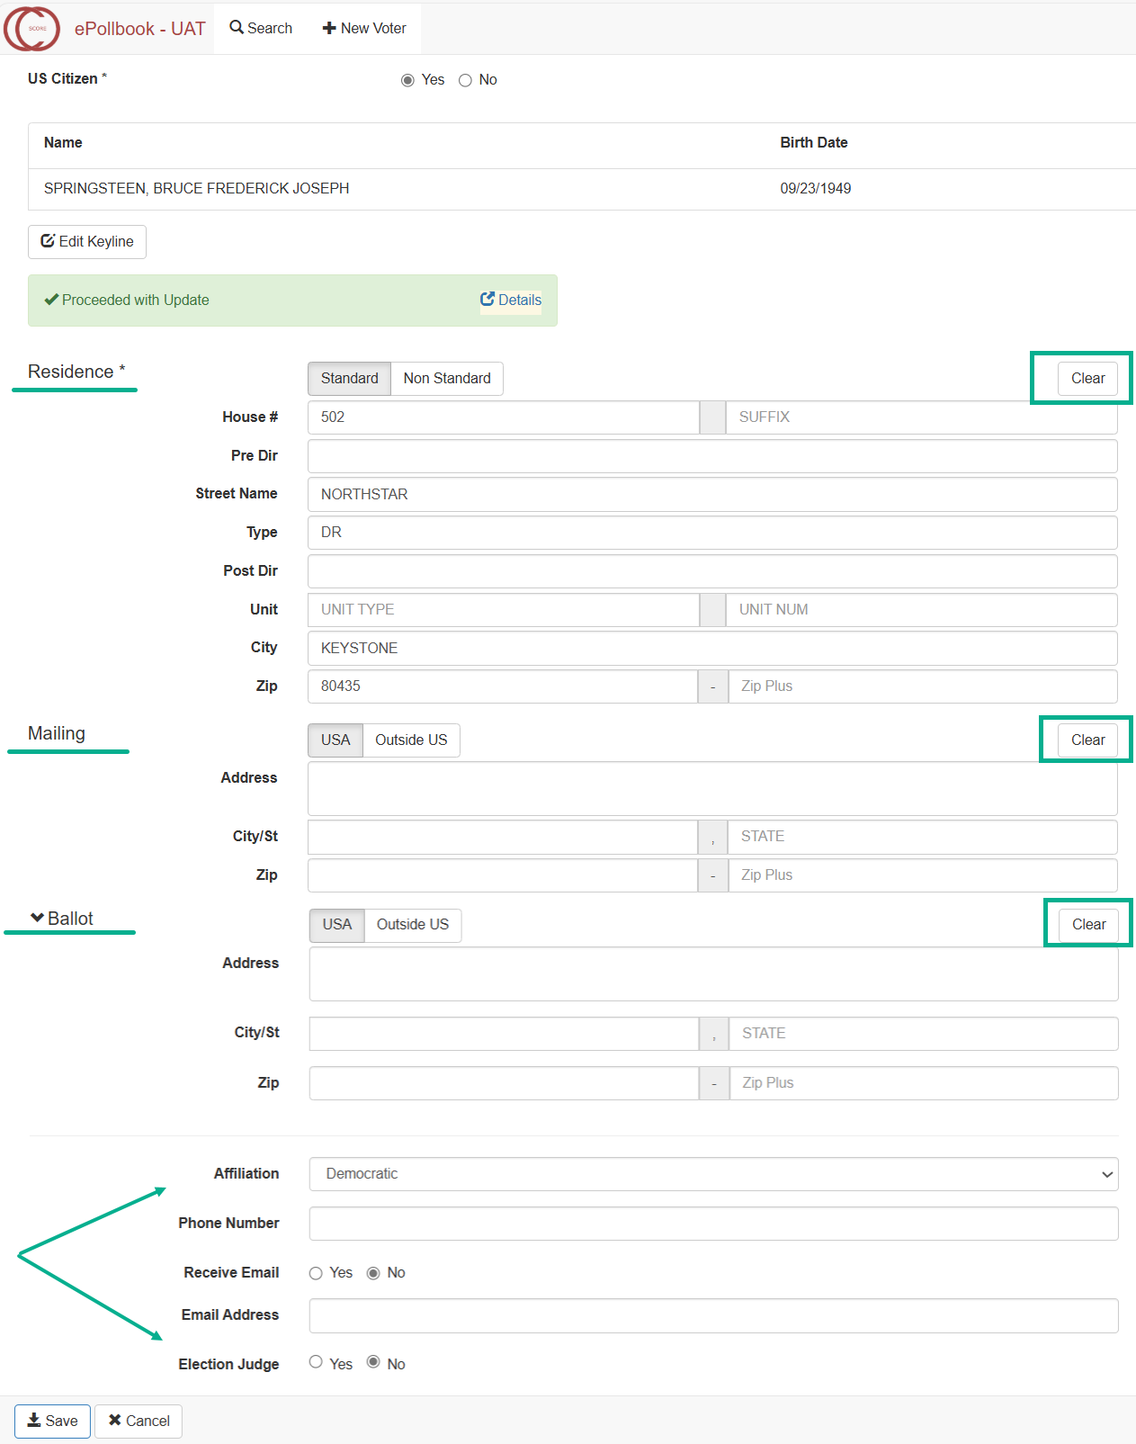

## Registering a New Voter

When a voter cannot be found after numerous voter search attempts, the voter must complete a VSPC Signature Combo Form to register to vote.

You must have the “VSPC Create New Voter” role to have access to the voter registration screen.

1. On the Search screen select the **New Voter** button.

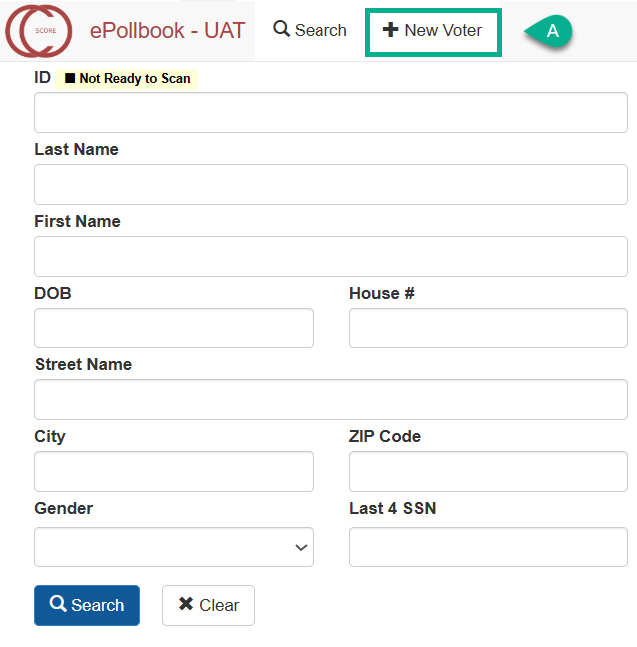

1. **US Citizen screen:** Select “Yes” or “No” to whether the voter confirmed US Citizenship.

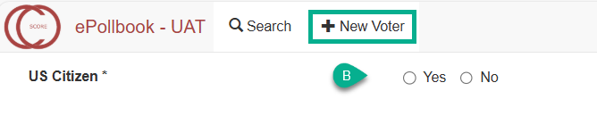

If you select “No”, the system will not permit you to register the voter. You will receive the message: Individual is not eligible message if No for US Citizen is selected.


































































*Registering a New Voter (continued)*

1. If you select “Yes”, the voter registration Keyline screen will open.

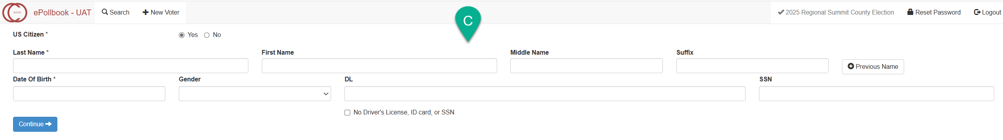

Enter the Keyline information. Fields with an (asterisk*) are required fields:

* Last Name**\*** First Name Middle Name Suffix Previous Name button to add a voter’s previous name
* Date of Birth**\*** Gender DL/ID SSN
* If neither DL/ID or SSN are provided, then place a check in the **“No Driver’s License, ID Card, or SSN”** box.

1. Select the **Continue** button.

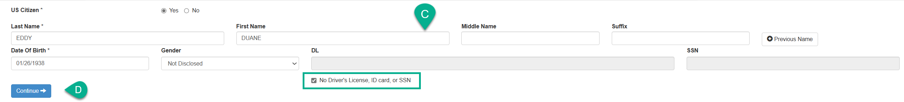

When you select the **Continue** button the system will perform checks against state agency data and against all voter records/statuses: Active, Inactive, Cancelled, Pending and Incomplete**.**

If the new voter information verifies against the system checks and a potential duplicate record is not found, you will proceed with registering a new voter.

*Registering a New Voter (continued)*

1. Proceed with entering Residence information.

The system defaults to the **Standard** residence tab.

The **Non Standard** residence tab is available and should only be used following your county business protocol.

The cursor defaults to House # in the Residence section.

Enter the voter’s **Residence** address in the designated fields.

[The **Street Name** will auto-fill as you type]

Once you enter a House # and Street Name, the Address Finder will search any matching address ranges in your county’s address library.

However, if you entered invalid residence address information (e.g., letters in the House# field), then the Address Not Found message will display.

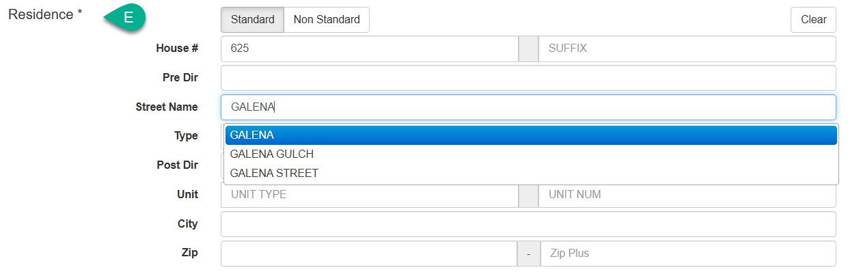

*Registering a New Voter (continued)*

If an address is flagged with a red indicator, additional information or a usable address must be entered. Otherwise, the system will not save the address.

**Red Indicators**

**Unit Required:** The example shows the address entered is unit required. Voters MUST provide **BOTH** the **Unit Type and Unit Number**. (Example, Apt 5, Bldg C- 41, #12). If unit type or unit number is missing, ask the voter to provide it on the VSPC Signature Combo Form.

**Unusable Address:**

The voter must provide a VALID Residential address. Voters cannot use a business/commercial address as a place of residence (Homeless persons are the exception, in which case, contact your Election Administrator)

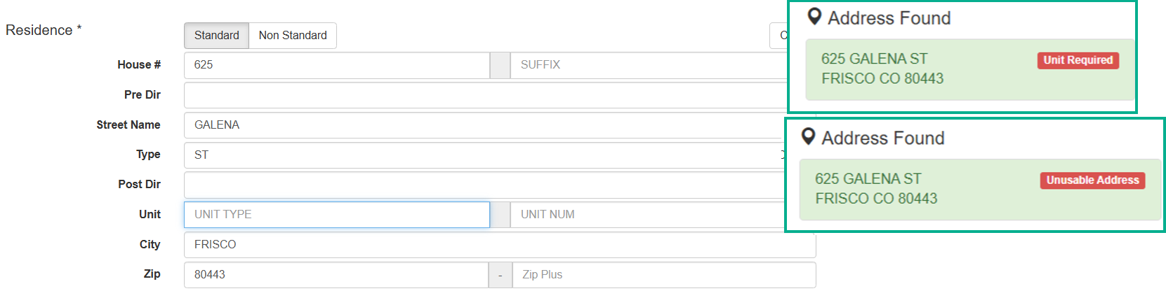

*Registering a New Voter (continued)*

Click on the correct address and verify the remainder of the information auto-populates.

*If it’s a unique address (meaning no other residential address in your county shares the same House#, Street Name, Street Type and City), the Address Finder will display the only matching address and auto-populate the remaining fields when you tab beyond the Street Name field.

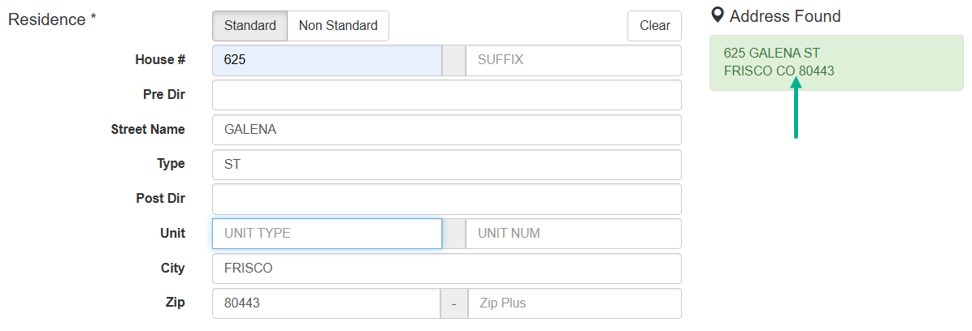

**NOTE: There is not a UOCAVA checkbox, UOCAVA must be flagged manually in SCORE 3.0. Contact your Election Administrator.**

*Registering a New Voter (continued)*

Work your way down the registration page.

1. Enter the voter’s **Mailing** address, if the voter has one.

International addresses must be entered in the “Outside US” tab.

1. Enter the voter’s **Ballot** address, if the voter has one. A Ballot address is a third address where the voter wants their ballot mailed.

International addresses must be entered in the “Outside US” tab

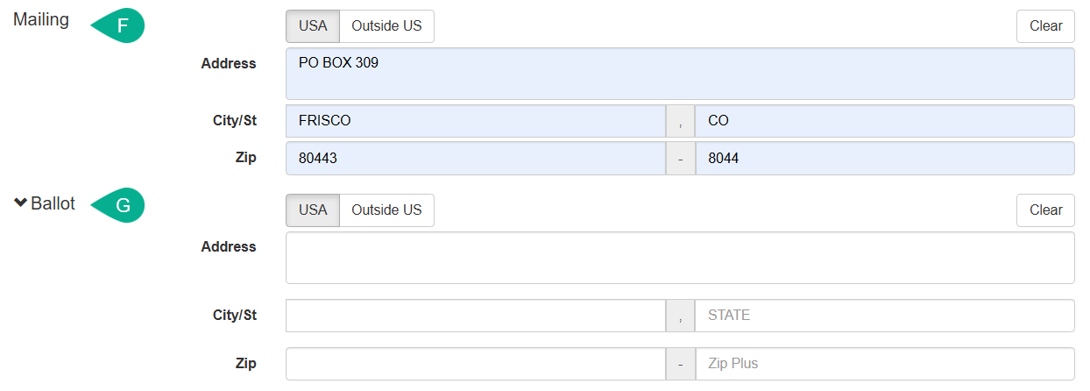

*Registering a New Voter (continued)*

1. Enter the remaining fields as provided by the voter.

Affiliation

Phone Number

Receive Email

Email Address (*Required if voter opts to receive emails)

Election Judge

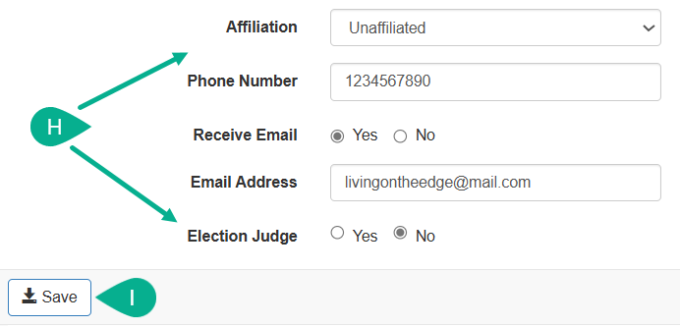

1. Click the **Save** button to save the changes to the voter’s record

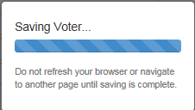

The voter record will automatically be saved as Active / 20 Day Period.

*Registering a New Voter (continued)*

Now you are ready to issue the ballot.

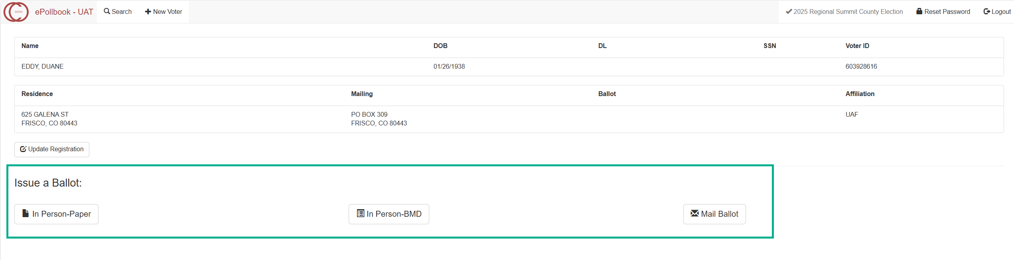

## Confined Voting - Voting Conducted at a Jail or Detention Center Facility

**It is critical that you select the correct Location for the facility you are working at.** If you do not do this correctly ballots will be issued from an incorrect location at which you are not working.

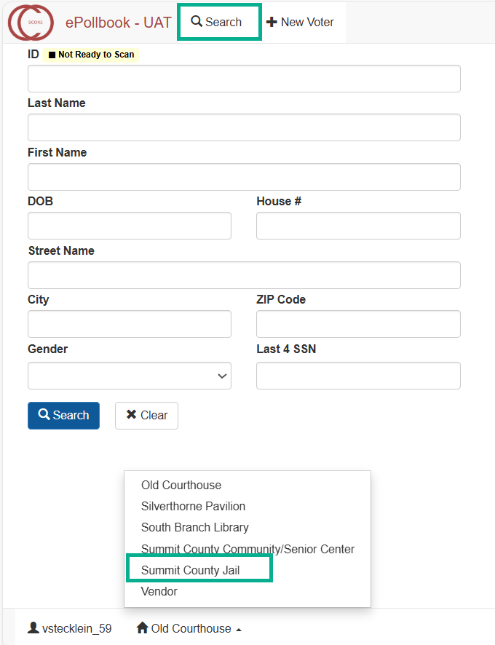

*Confined Voting (continued)*

Depending on your county’s process the order may be different:

1. Access the Colorado Department of Corrections Offender Search <https://www.doc.state.co.us/oss/> website and search by Name or DOC No.

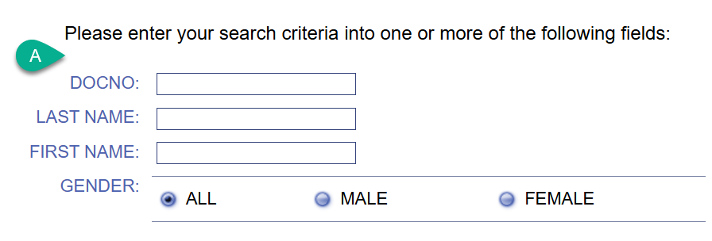

If the individual is eligible, you may continue the ePollbook process.

**DID YOU CHECK TO CONFIRM YOU ARE AT THE CORRECT LOCATION?**

1. On the ePollbook Search screen **Search** by **Name**.

Update a current registration if necessary.

If the record is not found, you will need to Create a New voter registration.

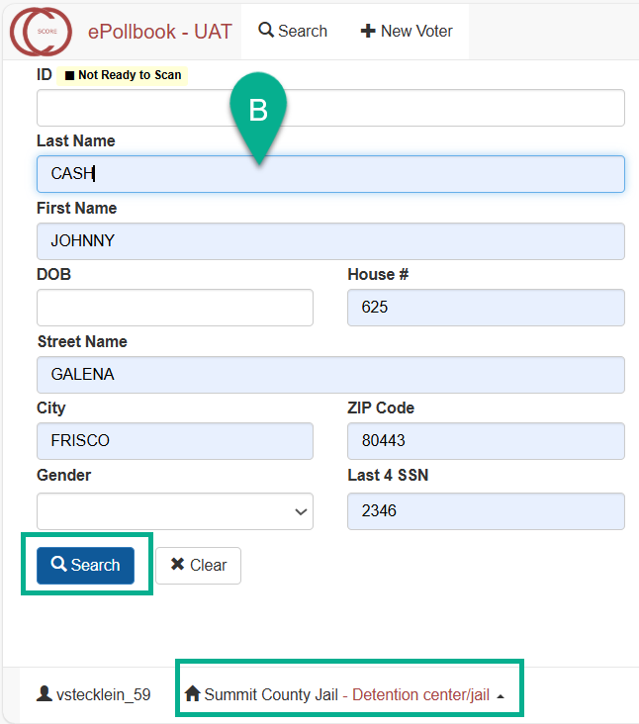

*Confined Voting (continued)*

1. Issue Ballot section is not available until you select Yes or No for the question: Is this voter confined?

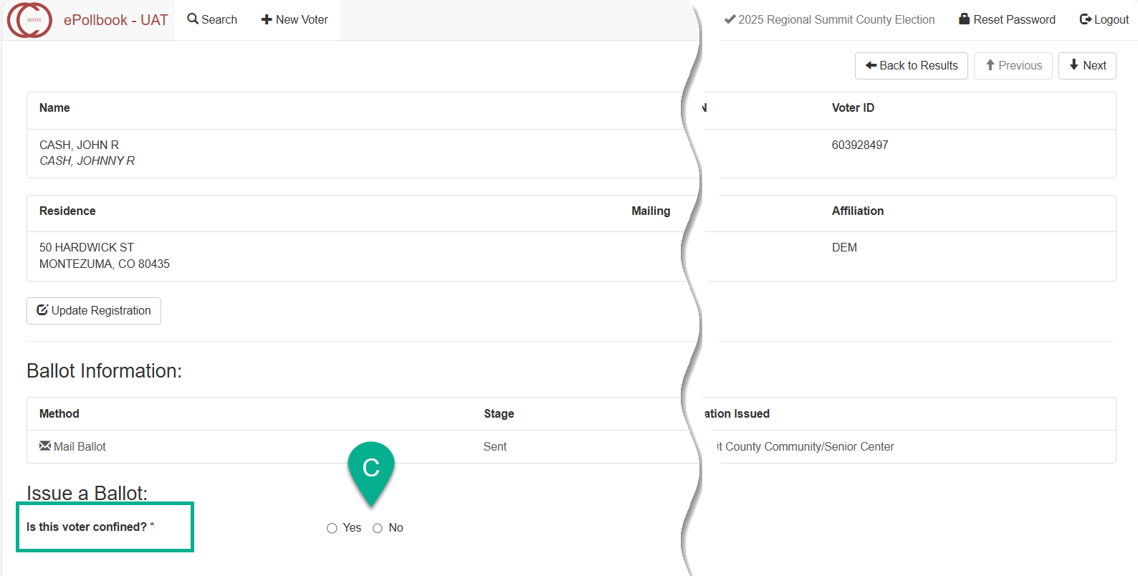

1. Issue a ballot.

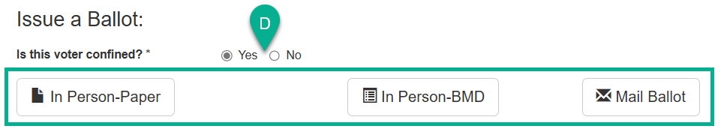

## Addendum A – Spoil a Ballot

Spoil is only available for in person ballots

**NOTE:** There is a 3-ballot limit for In Person voting. The system does not give a ballot limit pre-warning, but the In Person issue ballot buttons will be disabled by the system after the third ballot is issued.

There is no limit to the number of mail ballots that can be issued to a voter (until, of course, the voter casts their ballot).

If the voter mismarked or destroyed their In-Person Paper Ballot or In-Person DRE ballot, you should mark the ballot as spoiled and issue another ballot.

1. Pull up the voter’s record and click on the ballot you need to spoil. Make certain it is the correct ballot.

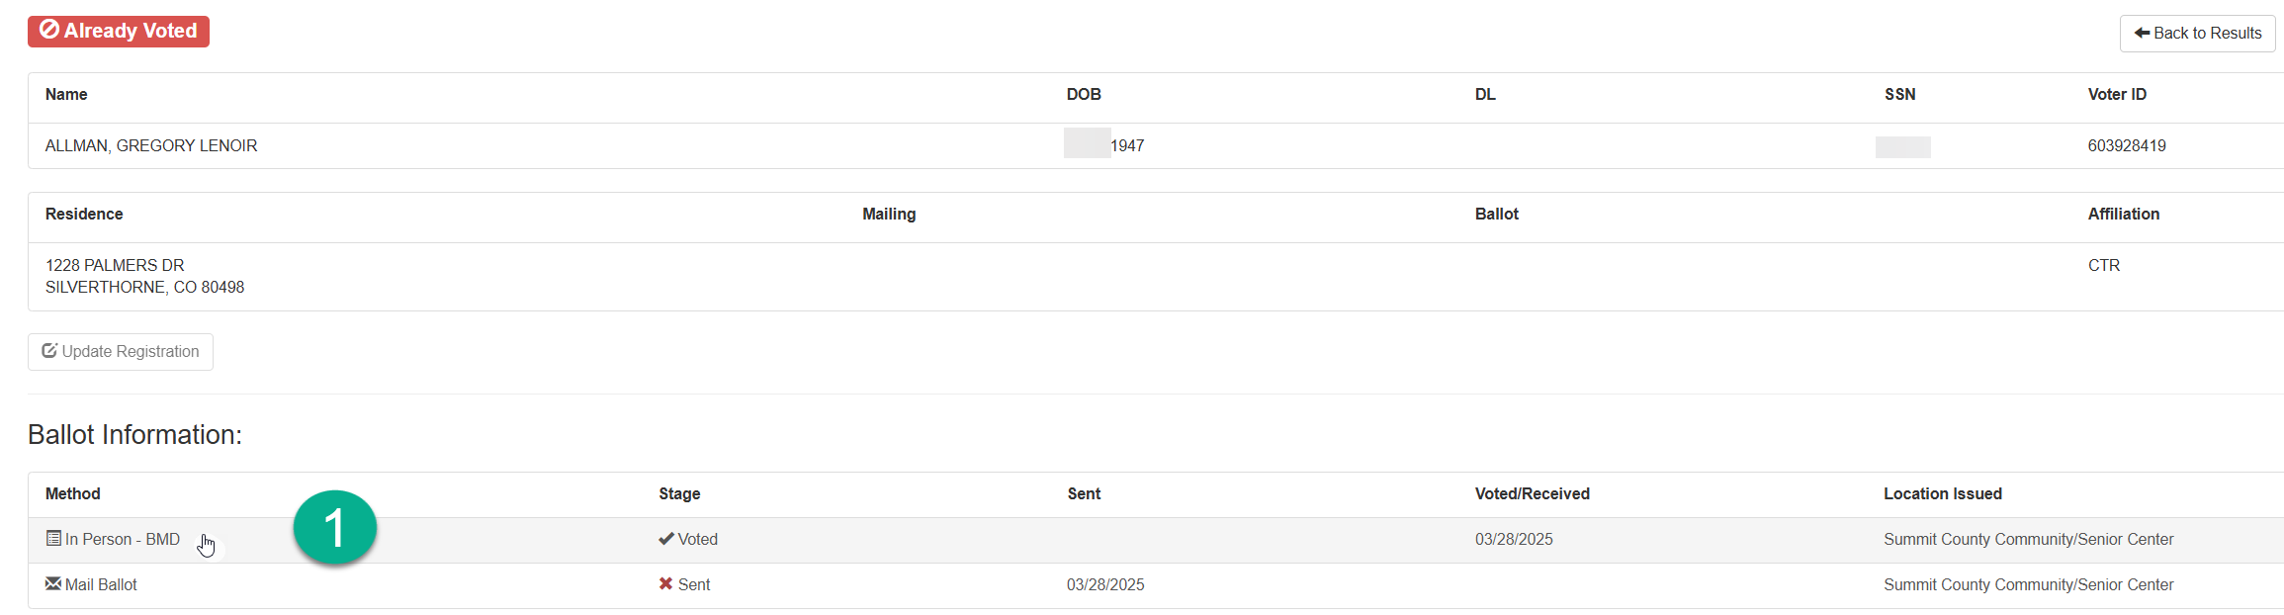

*Spoil a Ballot (continued)*

[The Ballot Details screen will open]

1. Click on the **Spoil** button.

[The top left corner of the Ballot Detail screen will display Ballot spoiled successfully]

1. Click on the **Close** button to close the Ballot Details screen.

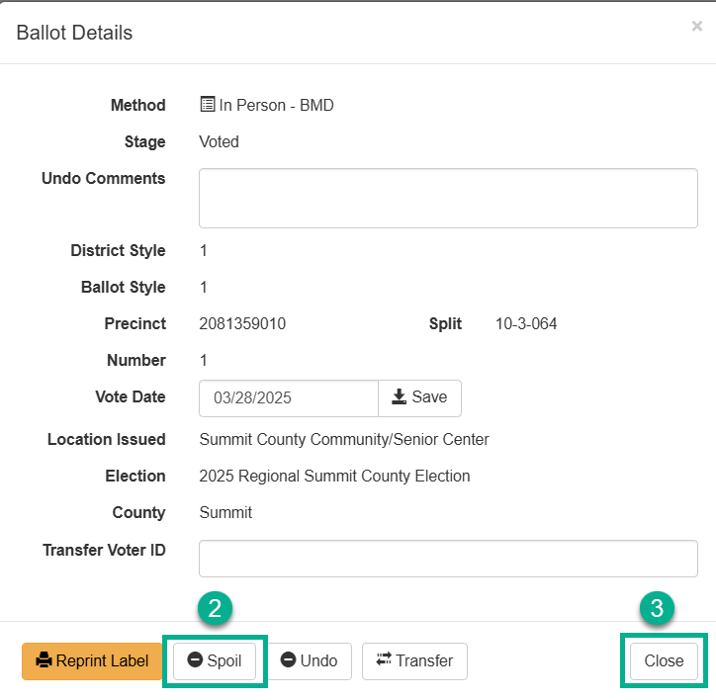

[The ballot line should display **X** Spoiled]

1. Issue the voter another **In Person** ballot (or mail ballot).

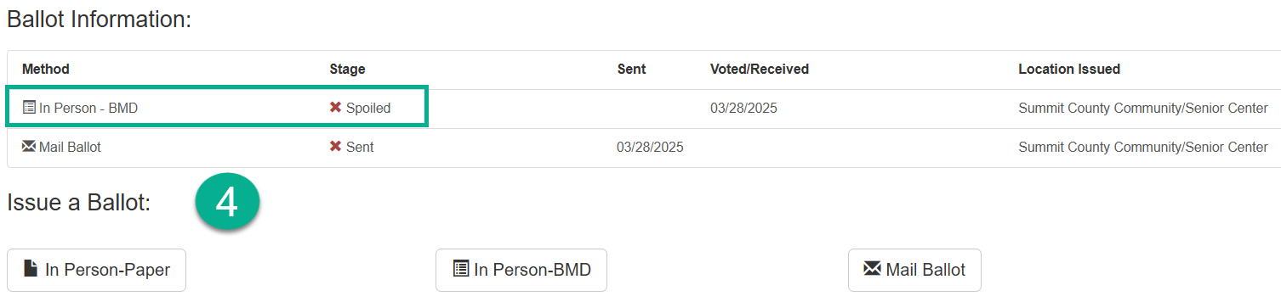

## Addendum B – Undo Vote Credit

If a ballot has been issued to a voter incorrectly (i.e., wrong voter), the vote credit may be “undone”.

This will issue an administrative void to the ballot and vote credit so that the voter may vote a regular ballot at a VSPC.

You must have the **VSPC Ballot Admin** role to undo vote credit.

1. Pull up the voter’s record and click on the ballot that needs to be undone. Make certain it is the correct ballot.

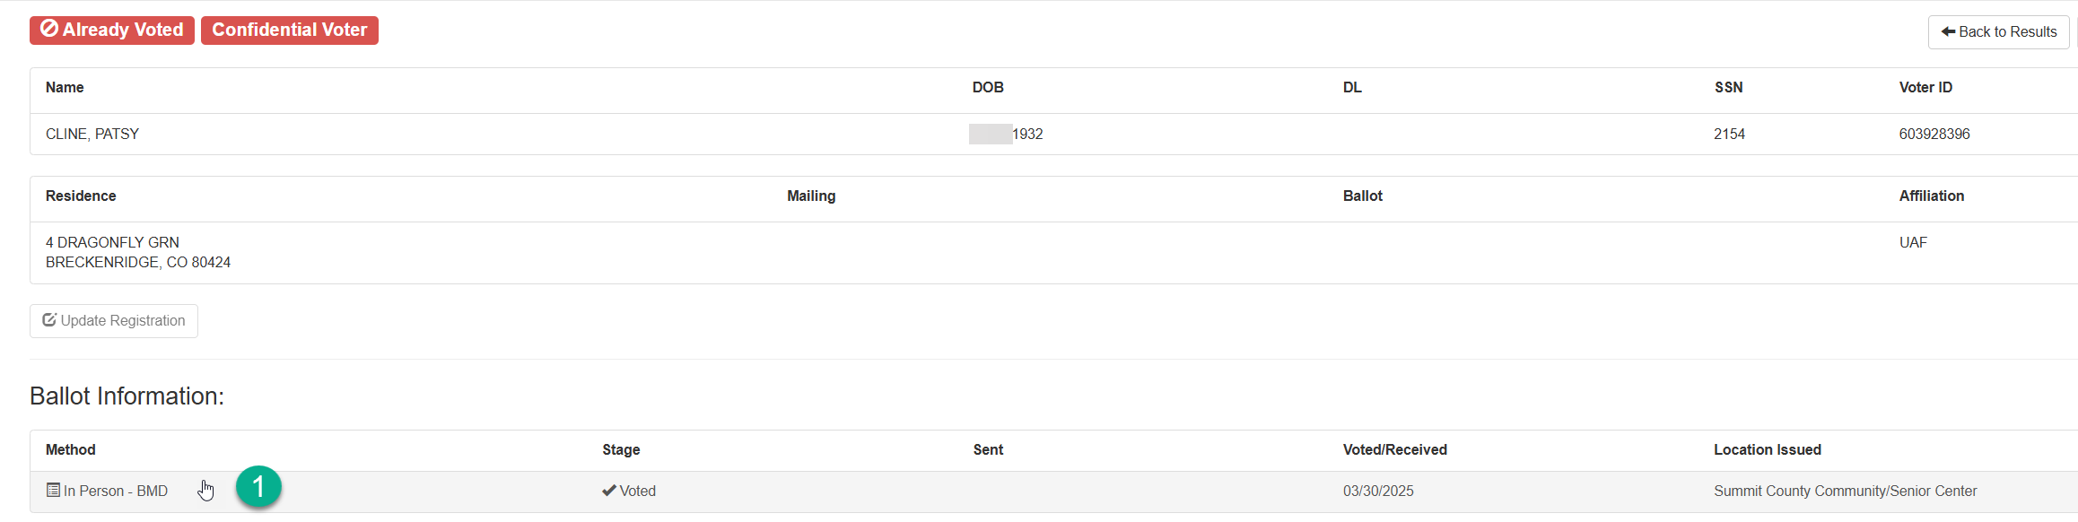

*Undo Vote Credit (continued)*

[The Ballot Details screen will open]

1. Enter a reason in the **Comment** box to document why the ballot is being undone.
2. Click on the **Undo** button.

[The top left corner of the Ballot Detail screen will display Ballot Undone successfully]

1. Click on the **Close** button to close the Ballot Details screen.

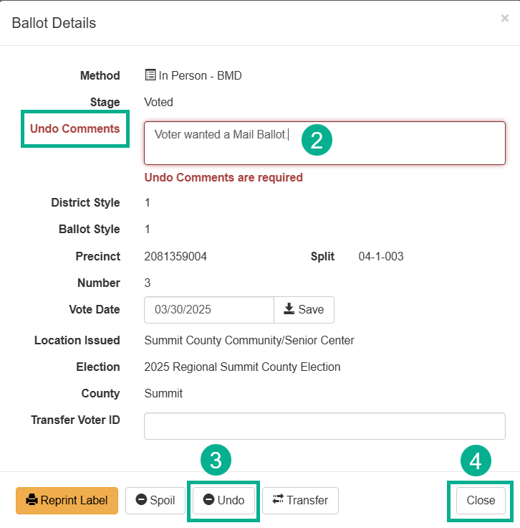

[The ballot line should display **X** Undone]

1. Issue the voter another ballot, if necessary.

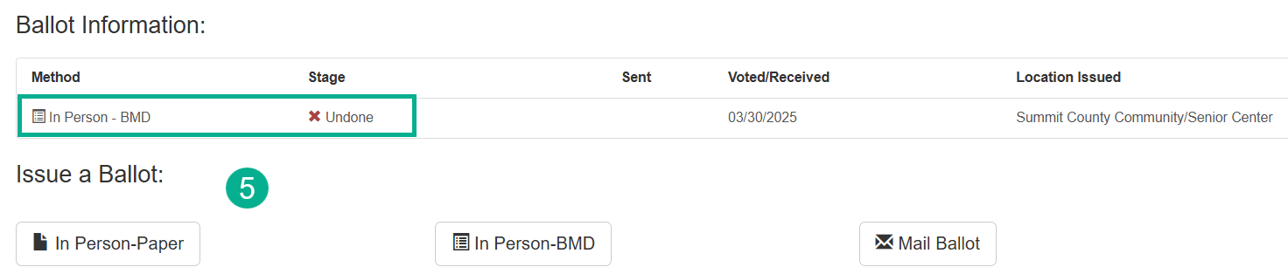

## Addendum C - Transfer Ballot

You **cannot** transfer ballot(s) to a voter who has already voted.

You **cannot** transfer ballot(s) to a non-survivor record that has been merged.

You may need to transfer a ballot from one voter to another if you have issued a voter credit in error. This is a common mistake when a Junior/Senior reside in the same county.

You must have **VSPC Ballot Admin** role to transfer in-person ballots.

**Research**

1. Search for both voters to research what actions transpired.

In this example: Dee Ray Daines JR (Voter A) has In Person vote credit, but it was given in error.

It was actually DeeRay Daines SR (Voter B) that voted at the VSPC, however Voter B still has a mail ballot in the “Sent” stage.

1. Write down the Voter ID# for each voter.

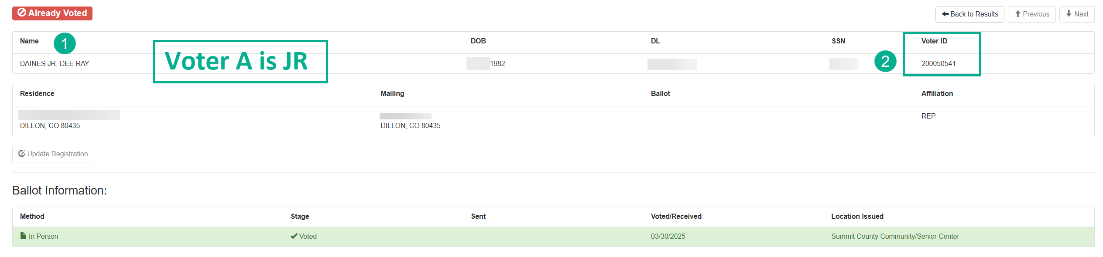

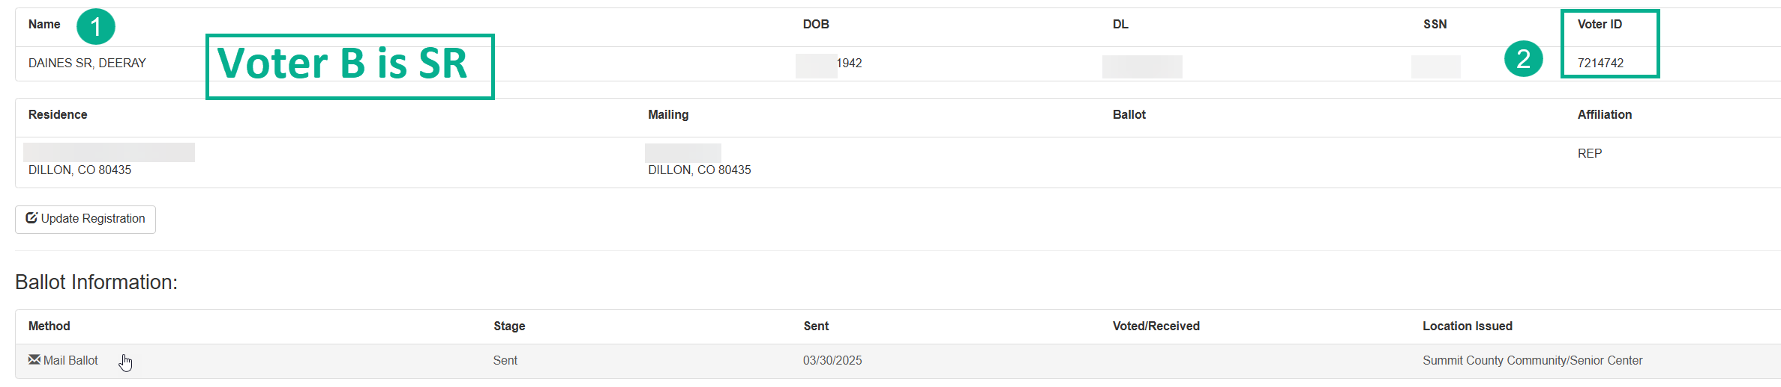

*Transfer Ballot (continued)*

**Transfer in-person vote credit from voter A to voter B, so the correct voter receives credit for voting.**

1. Pull up the voter record for **Voter A** who has In Person vote credit and click on the **Voted** ballot line. Make certain it is the correct ballot.

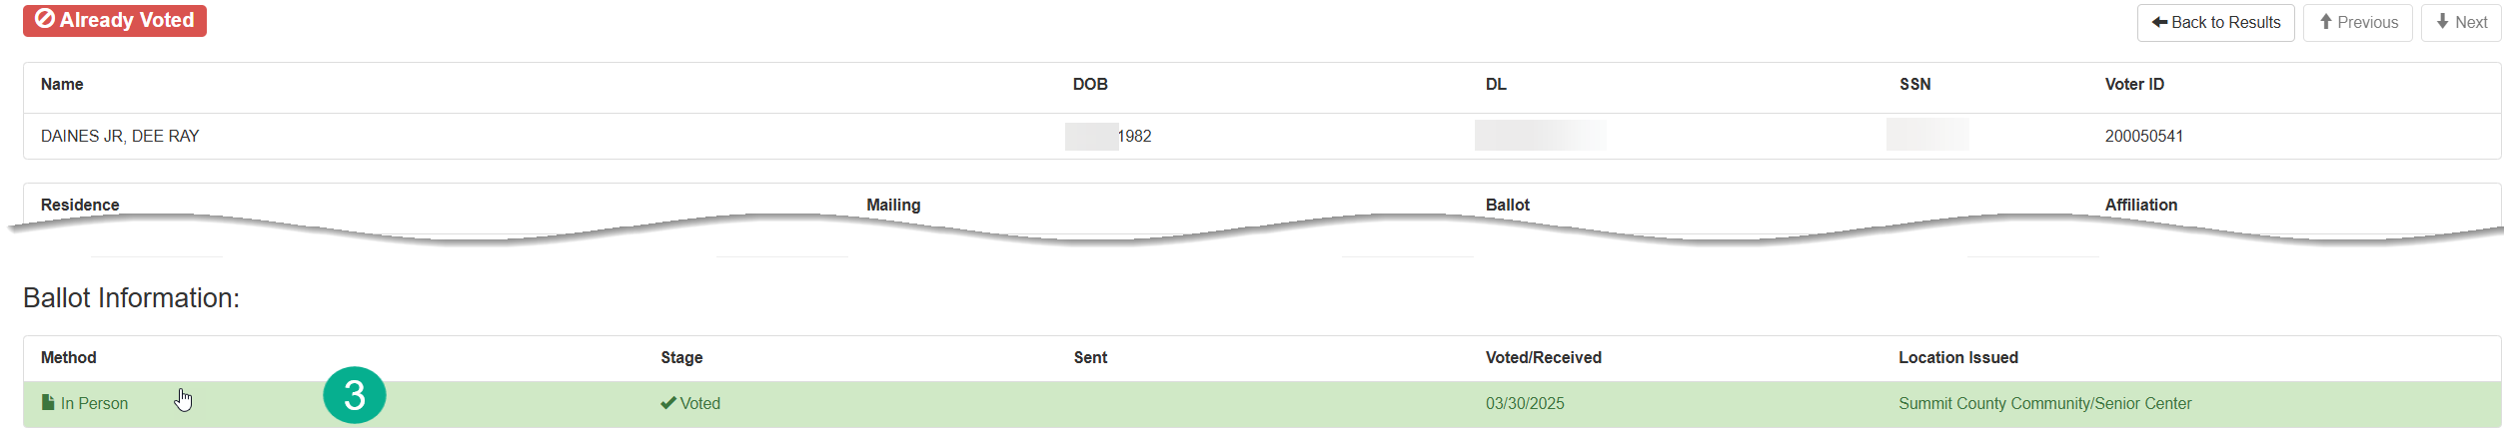

[The Ballot details screen will open]

1. Enter the Voter ID# of **Voter B** to whom the ballot will be transferred in the **Transfer Voter ID** field.
2. Click the **Transfer** button.

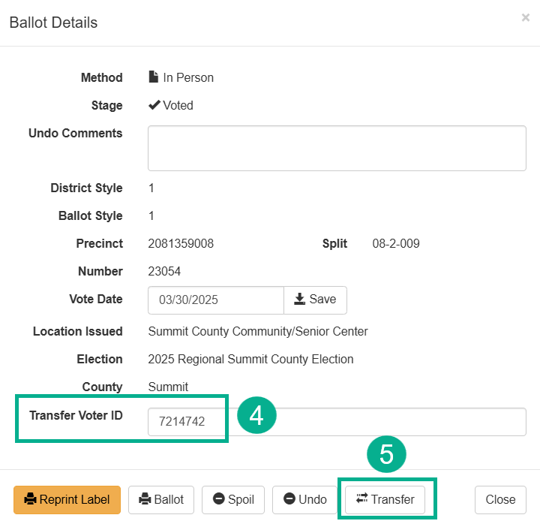

*Transfer Ballot (continued)*

1. Verify Transfer message and click **OK** only if it is correct. Otherwise, click the Cancel button.

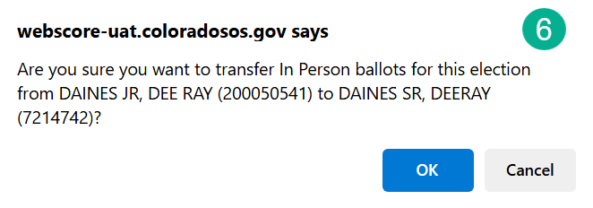

[The top left corner of the Ballot Detail screen will display Ballot successfully transferred to Voter#]

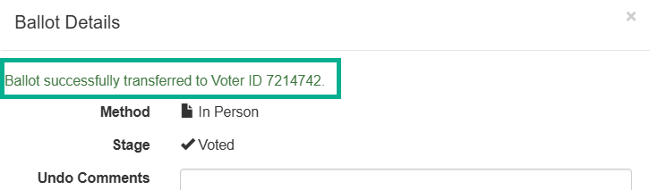

**The In Person ballot has transferred to Voter B**.

## Addendum C - Transfer Ballot Cleanup

Now you must cleanup Voter A’s record by “unvoiding” the mail ballot because Dee Ray Jr is still eligible to vote.

1. Click on the ballot line for the voided mail ballot.
2. On the Ballot Details screen, click on the **Unvoid** button.
3. Click the **Close** button.

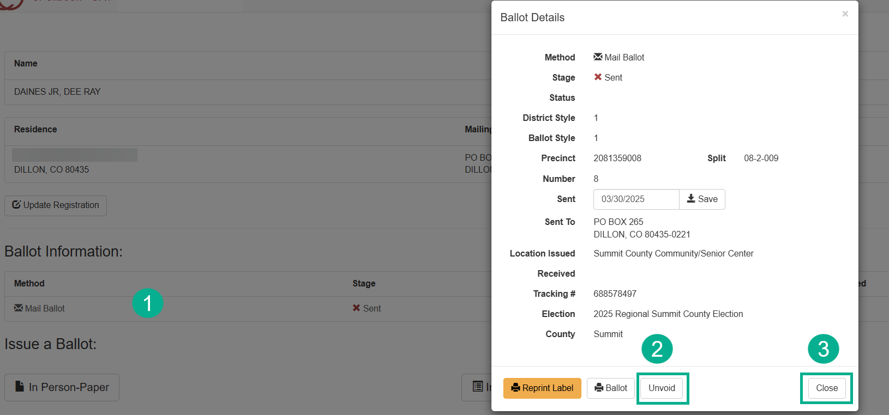

[The top left corner of the Ballot Detail screen will display Ballot unvoided successfully]

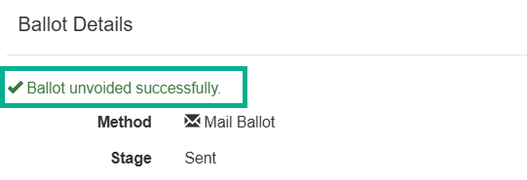

Now the voter has an Active Mail ballot.

Transfer Ballot Cleanup *(continued)*

The In Person ballot was transferred to Voter B. Now you must cleanup Voter B’s record by “voiding” the mail ballot.

1. Click on the ballot line for the Active Mail ballot.

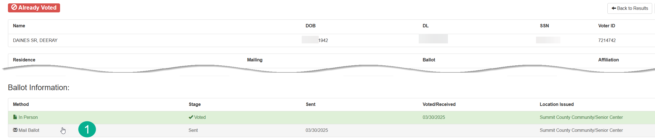

1. On the Ballot Details screen, click on the **Void** button
2. Click the **Close** button.

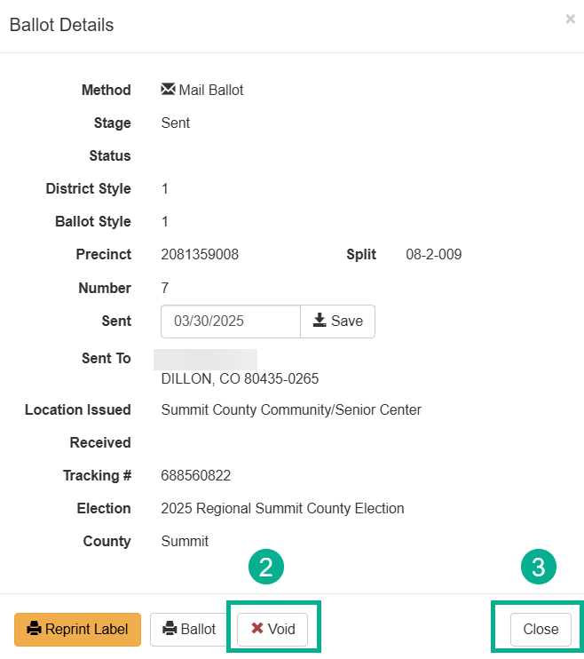

Transfer Ballot Cleanup *(continued)*

[The top left corner of the Ballot Detail screen will display Ballot voided successfully]

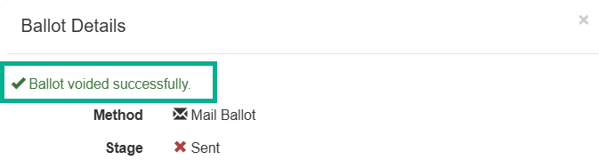

[The ballot line should display **x** Sent]

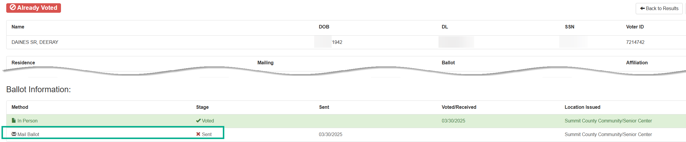

## Addendum D- Voter Has Multiple Records

|  |  |
| --- | --- |
| **SCENARIO** | **SELECT** |
| **Active + Cancelled** | **Active record** |
| **Inactive + Cancelled** | **Inactive record** |
| **Incomplete + Cancelled** | **Incomplete record** |
| **Active + Inactive** | **Active record** |
| **Cancelled + Cancelled** | **Record with most recent County Reg Date** |
| **Combination of Active, Inactive, and Incomplete** | **Active record** |

## Addendum E - (CDOR) Colorado Department of Revenue

|  |  |
| --- | --- |
| **The CDOR Verification screen displays.**  **(Follow your county’s process. Contact your Election Administrator if directed)** | * Compare the information on the CDOR Verification voter line to the “You entered” line. * (Most Common) Look at the registration form and verify the correct spelling of the voter’s full name. Did the voter’s last name change? If the last name changed, it is still a voter match provided all other minimum matching criteria exists. * Verify Date of Birth, DL and SSN numbers were entered accurately. If the DL was entered correctly and it is being used by another voter, go into each voter record to view scanned images or CDOR Search to resolve the discrepancy. * Click the Edit Keyline button to correct typos, if applicable. Then Perform Checks again to initiate another SCORE check. * After researching and resolving the discrepancy, respond to the CDOR question “Is this the voter’s CDOR record?” to proceed. |

## Addendum F - (CDOC) Colorado Department

|  |  |
| --- | --- |
| **The CDOC screen displays and the record is not a match.**  **(Follow your county’s process. Contact your Election Administrator if directed)** | Click No Match – Proceed with Update (or New Voter).  Continue processing the voter. |
| **The CDOC screen displays and the record is a match,**  **and the voter states they are on parole.** | The voter is eligible to vote.  Click No Match – Proceed with Update (or New Voter).  Continue processing the voter. |
| **The CDOC screen displays and the record is a match,**  **and the voter states they are eligible, but it is determined they are not eligible.** | The voter is not eligible to vote.  Click on the matching felon record.  ePollbook will not allow you to issue a regular ballot; however, you can issue a provisional ballot if the voter insists on casting a ballot. |
| **The CDOC screen displays, and the voter claims that they:**   * Were cancelled in error. * Are not currently serving a sentence or confinement for a felony conviction. | Have the voter fill out the VSPC Signature Combo form or the Colorado Voter Registration form.  Click No Match – Proceed with Update (or New Voter).  Continue processing the voter. |

## Addendum G - (CDPHE) Colorado Department of Health

|  |  |
| --- | --- |
| **The CDPHE screen appears, and the record is not a match.**  **(Follow your county’s process. Contact your Election Administrator if directed)** | Click No Match – Proceed with Update (or New Voter).  Continue processing the voter. |
| **The CDPHE screen appears, and the record is a match.** | Research the validity of the cancellation.  An individual who was cancelled because of a CDPHE match that they believe was erroneous has 2 options:  The person can present ID and explain that the match was an error; or the person can provide a signed statement that includes their name, residential address, date of birth and explanation of the error. If the elector does either, their record should be made Active (reinstated with the correct dates). |